# Our Commentary about the Sidewalks

Abstract

With the improvement of the quality of life, people like to walk more, so whether to have a reasonable and solid sidewalk seriously affects people's daily life. On the one hand, the sidewalk affects people's daily life; on the other hand, people usual has a certain counter-effect on the sidewalk, and the influence of this interaction is huge. Therefore, when we consider the order of restoration, we need to comprehensively consider the impact of many aspects, including this huge mutual influence. Based on the sidewalks of The City of Ithaca, we explored the establishment of mathematical models to reasonably evaluate the order of restoration, and made the optimal repair procedures, and at the same time made reasonable repairs to future sidewalks.In the end, the city manager need a professional report that does not involve technology.

We first applied the four influencing factors, and then selected the completeness of the slabs; whether the vertical displacement at the interface between adjacent slabs exceeds ½ inch; whether the running slope is more than 2%; Whether the cross slope is at least 1% and at most 2% other 4 evaluation sub-indexes, all influencing factors are quantified. Then we obtain the weights of the two levels of indicators through AHP, which are  and , and construct the repairing evaluation model from this.

Secondly, we use the method of reconciliation and projection to find the width of the actual sidewalk bricks, and use this as a basis to find the best repairing plan. In the process of establishing the plan, we first use the method of classification and discussion to find the money need of each independent repairing plan, then use the volatility function module to integrate these independent plans, and then use the unimodal function relationship to calculate all the plans, using the reasonable data found to substitute into each specific plan and calculate the amount that all plans needed, in order to select the solution that requires the smallest total amount limit. Finally we choose the third-equal division method to solve the problem.

Then we need to find valid data and use this data to find the budget for the sidewalk repairs in the future years. We infer the amount of sidewalk repairs in the city in future by finding the amount of repaired sidewalks in recent years and use this as a base point. We reasonably use the function to simulate the integrated model to calculate the trend of the amount of money that will be spent in the next few years.

Finally, using the information we have and prepare a one-page executive summary of your results for The City of Ithaca Sidewalk Program Manager .

Key word: **Fuzzy Comprehensive Evaluation Method analytic hierarchy model polynomial fitting**

### Contents

1. Introduction ------------------------------------------------------------------------------ 2
   1. Background
   2. Problem Restatement
2. Assumptions and Justification --------------------------------------------------------- 2
3. Notations ---------------------------------------------------------------------------------- 3
4. Model Construction --------------------------------------------------------------------- 3

4.1 Problem Analysis

4.2 Model Design

4.2 Solution for Part I

5. Optimal repair procedures --------------------------------------------------------------- 8

5.1 Problem Analysis

5.2 Model Establishment

5.3 Model Solution

5.4 Evaluation of Both Strategies

6. Projecting future needs ---------------------------------------------------------------- 14

6.1 Problem Analysis

6.2 Model Solution

7. Model Analysis ------------------------------------------------------------------------- 18

7.1 Advantages

7.2 Disadvantages

7.3 Sensitivity

8. A Report for the manager of The City of Ithaca ------------------------------------ 20

Reference ----------------------------------------------------------------------------------- 21

Appendix ----------------------------------------------------------------------------------- 21

### 1 introduction

#### Background

People are increasingly attracted to walkable neighborhoods. Typically made as a sequence of concrete slabs, sidewalks are often damaged by tree roots growth, repeated freezing & thawing of the ground, other soil erosion processes , or excessive weight loads. In addition, the construction of a new sidewalk is also planned. Although the funding for the sidewalk improvement program is increasing year by year, it still cannot fully meet the demand.

On the one hand, we must give priority to investing limited funds in more important places, "good steel must be used on the blade"; on the other hand, for the repair of each path, we must reduce the cost as much as possible. In addition, we have to make predictions on future funding requirements and write a letter of recommendation to the relevant administrative department based on the information we have already obtained.

#### 1.2 Restatement

**Part I:** [Offer](D:/Dict/8.9.3.0/resultui/html/index.html" \l "/javascript:;) [a](D:/Dict/8.9.3.0/resultui/html/index.html" \l "/javascript:;) [proposal](D:/Dict/8.9.3.0/resultui/html/index.html" \l "/javascript:;) to improve the algorithm for computing a priority score of repairing for each city block.

**Part II**: Provide an optimal repair procedures for a small road that needs repair.

**Part III**: Forecast the funds needed for future sidewalk improvement plans.

**Part IV**: Write a one-page executive summary of your results for Mr. John Licitra, The City of Ithaca Sidewalk Program Manager.

### 2 Assumption and Justification

* The upper and lower surfaces of each slab are square, and the side lengths of all slabs in a street are the same (that is, slabs with different side lengths will not be connected to each other);
* In a street, the direction of the sidewalk remains unchanged and parallel to the lane;
* The destruction of external force will not cause the slab to translate along the ground (if translation occurs, we think that the brick is damaged and needs to be replaced);
* Cutting is more difficult than Raising, and it can include raising operations when cutting slabs;
* Our maintenance costs do not include maintenance costs for slabs and road edges;
* The inflation rate of each cost is fixed, that is, its annual growth rate is a constant;
* Every year, the length of roads damaged due to weather and other factors accounts for a linear relationship with the total road length;
* The cost change of cutting and raising road is consistent with the change of material cost;
* The length ratio of cutting and raising roads in the same year is always the same, that is, a single unit cost can be used to replace the respective costs of the two when calculating expenses;
* Ignore the influence of foreign population;
* Assume that everyone in the unit walks to and from get off work in the same street area
* Assume that the inflation rate of each cost is fixed, that is, its annual growth rate is a constant ;
* Assume that the ratio of the length of damaged roads to the total length of roads each year due to climate and other influencing factors is a direct proportional function with respect to time;
* Assume that the cost change of cutting&raising sideway is consistent with the change of material cost;
* Suppose cutting and raising sideway remain the same in the same year, that is, a single unit cost can be used to replace the costs of each in the calculation of funds.

### 3 Notations

|  |  |
| --- | --- |
| symbol | Definition |
|  | Population density |
|  | Proximity to schools, bus stops, governmental buildings |
|  | Number of complaints |
|  | The physical condition of concrete slabs |
|  | The [completeness](D:/Dict/8.9.3.0/resultui/html/index.html" \l "/javascript:;) of the slabs |
|  | Whether the vertical displacement at the interface between adjacent slabs exceeds ½ inch |
|  | Whether the running slope is more than 2% |
|  | Whether the cross slope is at least 1% and at most 2% |
|  | the final combination weight vector |
| In which | The ratio of sub-indicators |
| A | The index score vector |
|  | Final score |
|  | Sub combination weight vector |
|  | Sub index score vector |
|  | Height of the complete slabs |
| In which | Each costs of slabs recovering |
|  | Car width |
|  | The width of the sidewalks |

### 4 Model Construction

#### 4.1 Problem Analysis

Question one has four main requirements:

(1) The four main indicators given in the topic and the indicators under the physical condition of concrete slabs are selected and ranked by importance.

(2) Sort the importance of the selected larger impact factor index to affect the repair order;

(3) Quantify all indicators in the two levels, and use mathematical methods to merge all indicators to obtain a comprehensive evaluation model about the order of repair. For data acquisition, we attach data samples and sources to the appendix. For the combination of indicators, in order to more directly reflect the degree of repair order, we adopt the fuzzy comprehensive evaluation method, that is, AHP and quantitative indicators, and find a combination method to solve the function model. Under the AHP level, the restoration order is the target layer, the personal evaluation degree and the public factor evaluation degree are the criterion layer, and the above-mentioned population density is used as the plan layer 1. The slabs should not be broken, etc. The five indicators are used as the second layer of the scheme, and the hierarchical analysis structure is established, and then the specific score value of each indicator is calculated through the function model, and finally a comprehensive evaluation model of the repair sequence is obtained through weighted summation. The higher the score, the more quickly it needs to be repaired.

#### 4.2 Model Design

The choice of indicators and the establishment of the model in question one.

**1. Selection of NHSS Evaluation Indicators:**

We searched related literature on Americans with Disabilities Act (ADA)* and found many indicators. After consulting related data and literature, we determined that **the physical condition of concrete slabs** has a larger impact factor as

Sub-indicator 1: **The [completeness](D:/Dict/8.9.3.0/resultui/html/index.html" \l "/javascript:;) of the slabs** (Broken ones,ones with sides less than 4 inches are illegal);

Sub-indicator 2: **Whether the vertical displacement at the interface between adjacent slabs exceeds ½ inch**;

Sub-indicator 3: **Whether the running slope is more than 2%**;

Sub-indicator 4: **Whether the cross slope is at least 1% and at most 2%.**

2. The distinction of indicators

We distinguish four indicators such as population density between personal evaluation and public evaluation:

From the perspective of personal evaluation, we selected one indicator: number of complaints;

From the aspect of public evaluation, we selected the remaining 3 indicators: population density, the physical condition of concrete slabs and proximity to schools, bus stops, governmental buildings;

1. Fix the quantization function of order evaluation index:

First, we define  as the total number of slabs on the target street.

• Construction of population density index quantization function:

Considering that the higher the population density, the higher the average traffic of the street, and the higher the demand for road quality, so the quantitative function of this indicator should be positively correlated with the independent variable (population density); on the other hand, the greater the population density , The more severe the damage to this road section, the more it needs to be maintained and repaired, so a non-linear exponential function is constructed to score.

We take the average population density of the city as a reference indicator, which is the perfect score indicator. With the aid of the actual population density  and average population density of road sections and streets, the population density index quantization function can be constructed:



• Construction of the quantization function about the proximity to schools, bus stops, governmental buildings:

For this indicator, we find out all the schools, bus stops, governmental buildings within the city area, and define it as the reference value of the full marks under the indicator, passing the schools, bus stops, governmental buildings that exist in each road section The relationship between the number of buildings  and the total number , the index quantification function of proximity to schools, bus stops, and governmental buildings is:



• The construction of the number of complaints indicator quantitative function:

We believe that the number of complaints (defined as ) reaching 0 is the goal that each road section should pursue, so it is used as a reference score for 0 points. The number of complaints  that reaches the number of resident population (defined as ) is the full score of the reference score. The higher the score, the more repair the road section needs. Therefore, the quantitative function of constructing the number of complaints indicator is as follows:



• The construction of the physical condition of concrete slabs index quantification function:

Since this indicator has five sub-indices, it is necessary to construct a quantified function for the five sub-indices, and then use the relationship of their weights to find the function value of the physical condition of concrete slabs indicator



In which the  is the weight of the indicators, and is the value of each sub-indicator, =1,2,3,4.

**Establishment of a comprehensive evaluation model for repairing sequence:**

Secondly , use AHP for 4 indicators such as population density: take the restoration sequence as the target layer, take the above-mentioned personal factors and public factors as the criterion layer, and use the 4 indicators such as population density as the plan layer to establish a hierarchy analysis result chart:

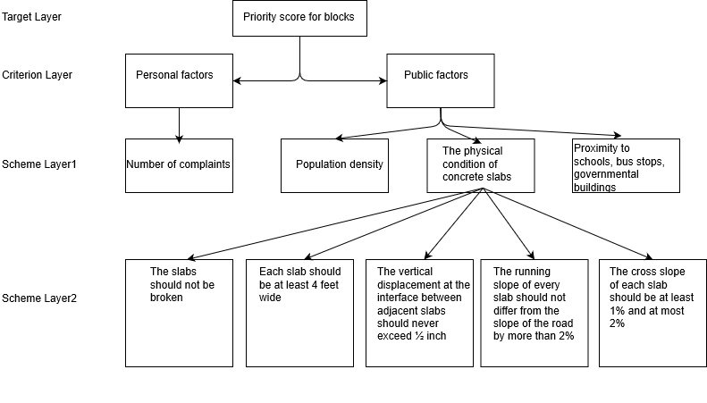

We sort the importance of each index from large to small, and construct a pairwise judgment matrix.

After calculating and checking the consistency of the judgment matrix, the final combination weight vector is:

Then the final comprehensive evaluation model of repair order is:



The index score vector is:



In which Z represents the scoring value of the repair order. The higher the score, the more priority repair is needed.

We consider the correlation between the various indicators under the physical condition of concrete slabs, so we define a large scale for unified measurement, and define the total number of slabs that do not meet the ADA conditions as , and at the same time define the full score of the reference score, because The higher the score, the greater the number and the need for maintenance. Then the ratio between the number of plates that do not meet the respective conditions and the total  in the five conditions is defined as, where  represents each index.

①The construction of the quantization function for Sub-indicator 1:

For this indicator, we define the distance between it and the standard condition (or the degree of non-compliance) as , which is decided by the ratio of  to . We determine that the function is exponential. Function, the function is:



②The construction of the quantization function Sub-indicator 2:

The construction of the quantization function Sub-indicator 2 is similar with Sub-indicator 1:



③The construction of the quantization function Sub-indicator 3:

The construction of the quantization function Sub-indicator 3 is similar with Sub-indicator 1:



④The construction of the quantization function Sub-indicator 4:

The construction of the quantization function Sub-indicator 4 is similar with Sub-indicator 1:



First, calculate A4 using 4 indicators selected from the physical condition of concrete slabs.

We sort the importance of each index from large to small, and construct a pairwise judgment matrix.

After calculating and checking the consistency of the judgment matrix, the final combination weight vector is:



The index score vector is:



Then the final comprehensive evaluation model of repair order is:



In which A4 represents the scoring value of the repair order, the higher the score, the more priority repair is needed.

**Consistency check**

Solved by the characteristic root method, the relative weight of each index is:

，



Calculate the consistency index of the two:

,

Calculate the agreement ratio:

,

It has been verified that the consistency of our judgment matrix is acceptable, for both are satisfied .

### 5. **Optimal repair procedures**

#### 5.1 Problem Analysis

Part C require us to construct an optimization algorithm for the fee of repairing the road. But in the previous part, we have not yet obtained any specific information about the road. So in this part, we are going to use the knowledge of projective geometry to analyze the street view photos in city of Ithaca in Google Map to find the width of the slab.

After that, we studied the general structure of the sidewalk in Ithaca and made the following schematic diagram. We assume that the structure of the road to be calculated is like this.

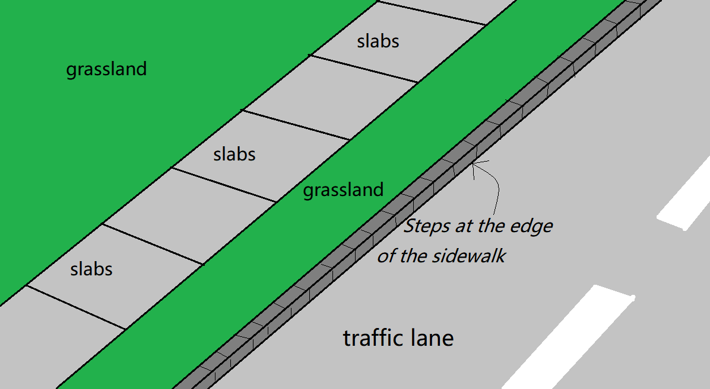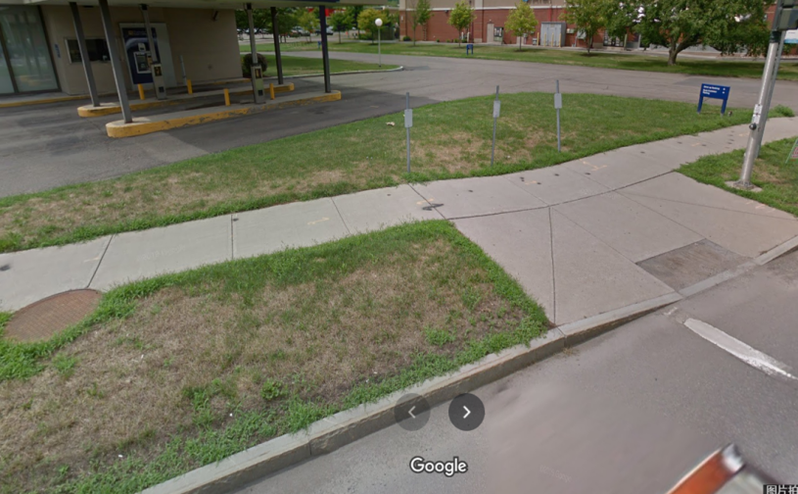

Figure : the simplification of the model

We simplify the angle and position of the stone brick to the position of the four vertices. If the coordinates of the four vertices cannot form a plane, then we will default the stone slab to be broken. By analyzing the coordinates of these four vertices, we can infer the running slope and the cross slope of the slab, as well as the vertical displacement.

Under normal circumstances, the slab will be broken or slightly inclined due to various reasons of weather and man-made. In this case, we will focus on the slate itself and the two adjacent slates, and perform a partial linear programming to determine whether to perform the above three operations on the slab. For convenience, we call it a smooth type. But in any case, we must also consider special circumstances, that is, due to special force majeure, such as a big tree growing on the roadside, or a large-scale traffic accident, many consecutive stone slabs have been raised or lowered as a whole. . This situation must be specially considered, because if we solve this situation by the method of solving the former situation, we may not be able to get the optimal solution. For convenience, we call it the undulating type. For the undulating section, we must first find out the specific range of the section, and then use the median method to solve it.

#### 5.2 The derivation process of the width of slab

Obviously, the shorter the side length of the slate, the more flexible the activities of repairing the slab can be carried out. But out of respect for the facts, we hope to obtain the true data of Slate as much as possible. Considering that the slabs used in different streets may not be the same size. Our test data will be based on W. Buffalo. St in Ithaca. W. Buffalo. St is a relatively wide and lively small street in the residential district of the city, which has a certain representativeness.

Using the relevant knowledge of projective geometry, we deduced the formula for finding the width of the road by using the ratio of the line segments in the photo and the data of the investigated cars. The formula is as follows:



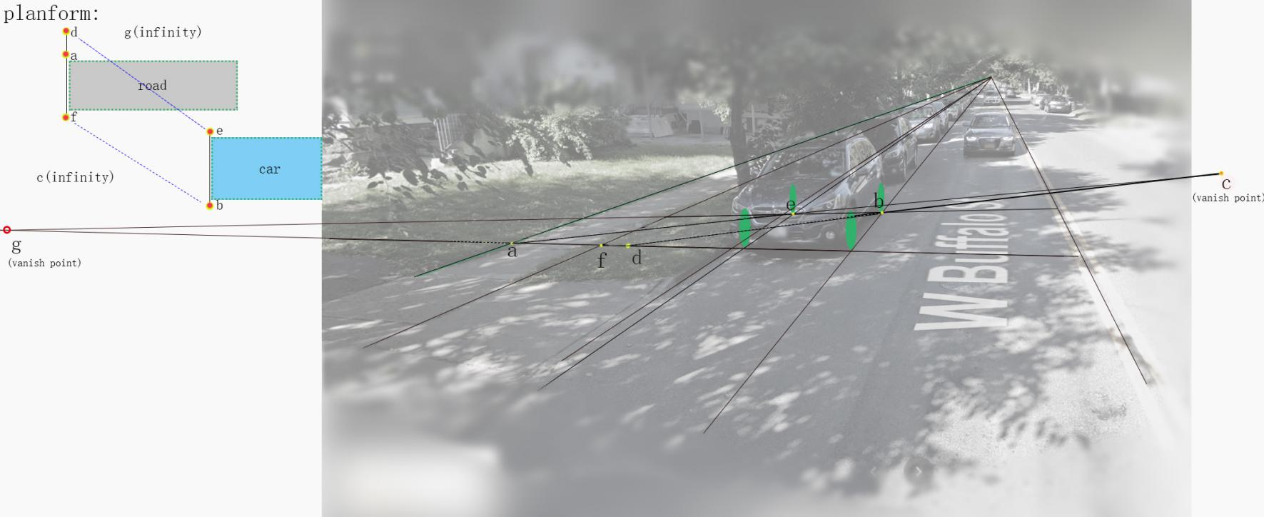In which 

Figure : the illustration of our algorithm

Finally we have w=58.242 inch.

Obviously, w satisfies the condition of "each slab should be at least 4 feet wide".

### **5.3 Data generation**

We first generated 6 slab roads with different conditions based on the data obtained in the data.The cross slope of each slab is measured from the inside of the road to the outside in order to allow for drainage. That is, the vertices of the flagstones near the two sides of the road are higher than the vertices of the flagstones near the center of the road when the road is built. Of course, the situation may be the opposite.

test1: Slabs were well protected.

test2: Slabs suffered mild harm because of temperature difference.

test3: After a term of lacks of maintainment slabs were uneven because of the growth of the trees along the road.

test4: Slabs suffered serious damage in extreme weather.

test5: The slabs were uneven for lacking maintainment for several years.

test6: Special case: Assuming a tree grows on the edge of a stone road, the root of the tree will form a cone

The slabs on these roads are broken and undulating.

We assume that the serial numbers of the slates on this street are from 1 to L, and we take L=200.(See the appendix for specific data)

### **5.4 Data review and preprocessing**

At this stage, we first check the vertical inclination of the stone road, and make a qualitative judgment to facilitate subsequent calculations. If most of the slabs are inclined to the inside, then we think the road is inclined to the inside. vice versa.

In the second step, we inspect the broken slate. Broken slabs must be replaced, so their original height is invalid. We find the continuous broken slabs and use the height of the complete slabs at their ends to perform a linear function interpolation.

In the third step, we need to find the segments in this road that apply the first method and the segments that apply the second method.



Figure : the illustration for the order of the slabs

If the following relationship is met:



Then we think this is a smooth road, otherwise it will be a bumpy road. It can be seen that this condition is very loose, because the second algorithm actually covers the first case, so we hope that the program will consider the overall situation as much as possible in order to arrive at the optimal solution.

In addition, we should first calculate the cost and effect of each operation:

Raising:changes the slope & position of the entire slab

it costs on average $5.13 per square foot of the slab.

Cost:

Cutting: Cutting involves removing a top slice of the slab, making its new surface have a different slope and elevation. This procedure costs on average $16 per linear foot of the slab, but it is only usable when removing at most 2 inches.

Cost: 

Replacing: Replacing a full slab costs on average $22 per square foot.

Cost: 

### **5.5 Classification processing: smooth type**

In the smooth type, we only need to consider adjacent slabs.We assume that the internal test of the road is higher than the outside (the situation where the internal test of the road is lower than the outside is similar, we will not repeat it here).

If a board has broken, then it must be replaced. We have solved this problem in preprocessing, so we won't repeat it here. Otherwise, we will use linear programming to solve the problem.

**Conditions that need to be met**:

the vertical displacement at the interface between adjacent slabs should never exceed ½ inch;

the running slope (i.e., in the direction parallel to the road) of every slab should not differ from the slope of the road by more than 2%;

the cross slope (i.e., in the direction perpendicular to the road) of each slab should be at least 1% (to allow for drainage) and at most 2% (to comply with the ADA).

**Expressed by the formula:**



When the above conditions are met, the value of the following formula should be minimized： 

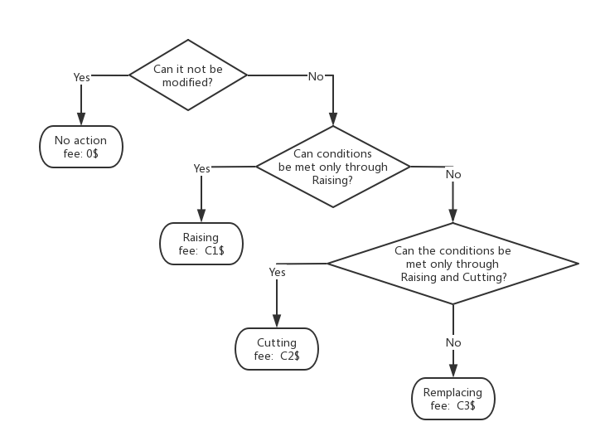

Figure : the flow chart of smooth type

It is worth noting that the above algorithms all need to consider the left and right slabs. Therefore, the first and last blocks do not conform to the above algorithm. But in this case, the first and last slabs do not need to be adjusted.

### **5.6 Classification processing: the undulating type**

In this case, we must first find the point where the rugged section deviates the farthest from the ideal smooth sidewalk (for example, if there is a pit in the road, then the center of the pit will become the farthest point). For convenience, we call it an evaluation point. Constantly adjust the final height of this point, and use this point as a benchmark to process it in the left and right directions (the processing method is the same as above), and calculate the cost of the entire rugged section at the current height of the evaluation point. Find the smallest cost, and the current plan is the best.

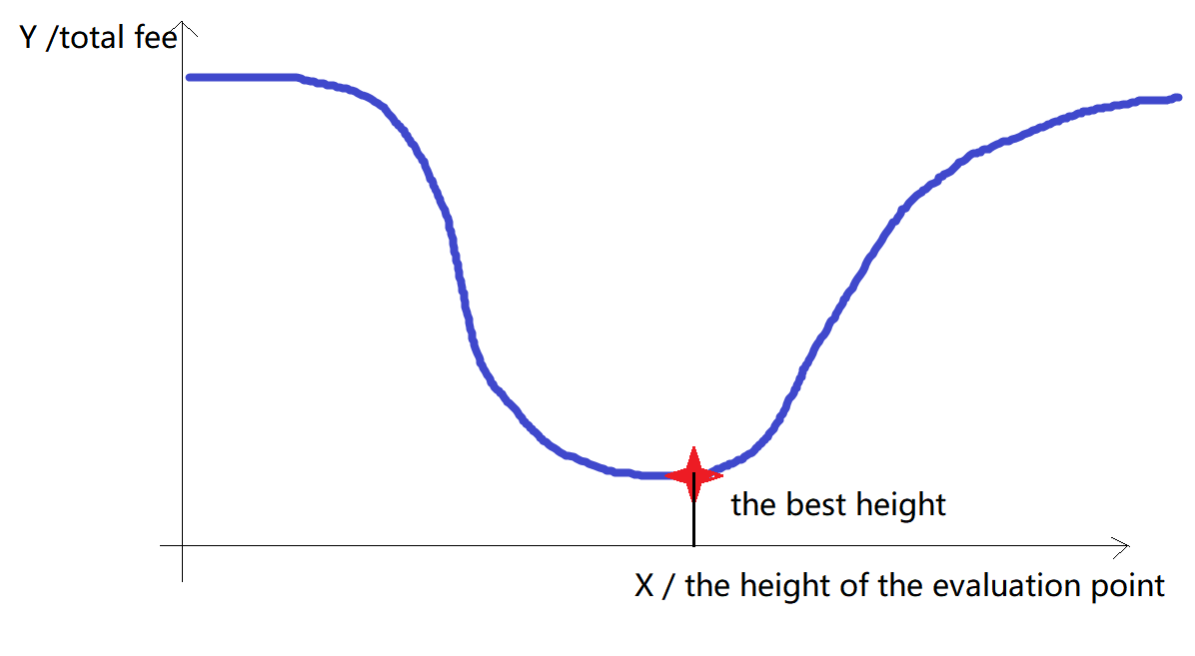

Figure : the unimodal function relationship

It is conceivable that if the evaluation point is too high or too low, the total price will be higher. If the height of the evaluation point is taken as the independent variable and the total price is taken as the dependent variable, their relationship will become a unimodal function. Therefore, we use the third-equal division method to solve the problem.

### **5.7 Algorithm test**

We used the above algorithm to calculate the maintenance cost of the small road we generated earlier, and the results are as follows:

|  |  |
| --- | --- |
| Test | Fee |
| Test 1 | 2640 |
| Test 2 | 5797.68 |
| Test 3 | 12797.4 |
| Test 4 | 17239 |
| Test 5 | 31516.7 |
| Test 6 | 40543.3 |

It can be found that as the degree of road fragmentation increases, maintenance costs increase.

### 6. Projecting Future Needs

#### 6.1 Problem Analysis

Question D asks for a projected increase in the budget for 2020-2045. We get that growth by forecasting the 25-year budget and then diverging it. As for the budget forecast, according to that the expenditure equals the product of unit cost and the quantity of built sideways, we first divided it into two parts, cost and sideways, and established mathematical models respectively. As for the cost, we refer to the variation law of the inflation rate and the obtained cost data, construct the corresponding function and calculate its parameter values through fitting. As for sideways, we divide them into new repairs (renovations) and maintenance, respectively, and obtain the results in the same fitting way.

#### 6.2 Model Construction

**1.Establishment of cost growth model:**

The scatter plots of material cost and sideway cost per unit length are shown as follows: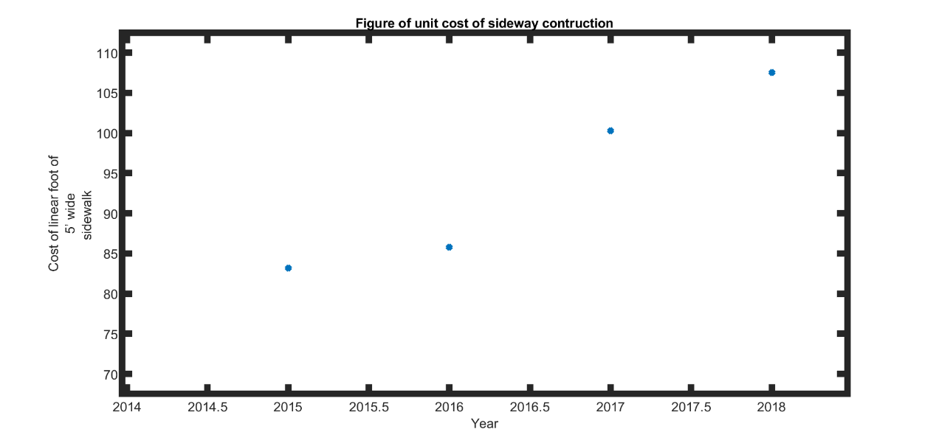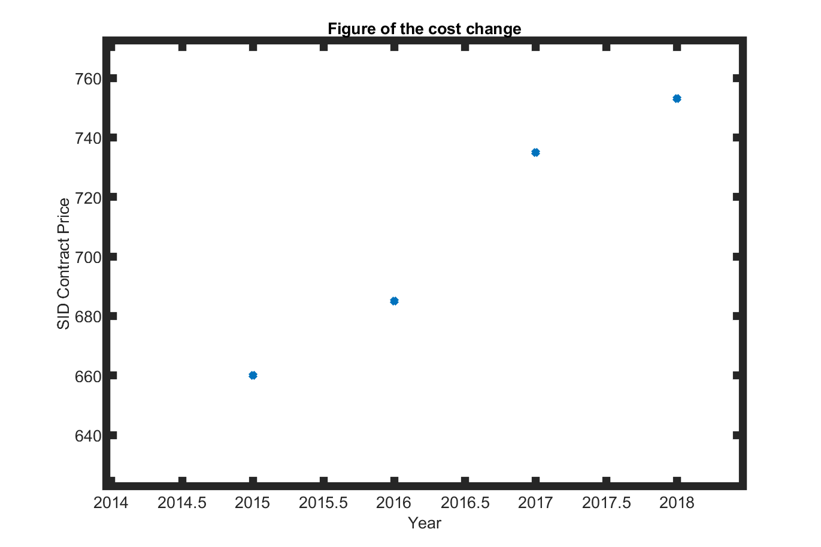

By searching online information, we finally chose 3% as the constant inflation rate and constructed the corresponding cost growth function as follows:

Where, represents the unit cost of year , are constants, represents the cost of material and cost of unit sideway length respectively.

The labor and material consumption of replacement and new construction are similar. Moreover, through comparison of relevant data, we can draw a conclusion that replacement and construction cost are basically the same (the SF cost of replacement is 22$in the question, while the SF cost of replacement for 2021 in the related report [1] is 23$). Therefore, Our default replacement and construction costs are the same per unit.

**2.Establishment of sideway maintenance model:**

We used the growth of the frontage fee in the report to reverse calculate the fuzzy value of the total sidewalk mileage in Ithaca in 2019:

For the new sideways to be built, we obtained the map from the city's website to obtain the length of the new sideways to be built from 2014 to 2019:

|  |  |  |  |  |
| --- | --- | --- | --- | --- |
| Year | 2015 | 2016 | 2017 | 2018 |
| Length/linear foot | 6086.34 | 4296.41 | 620.12 | 3681.60 |

Due to the large deviation between the 2017 data and its adjacent years, it is not taken into account in the fitting. A fitting image of the total road length is given below:

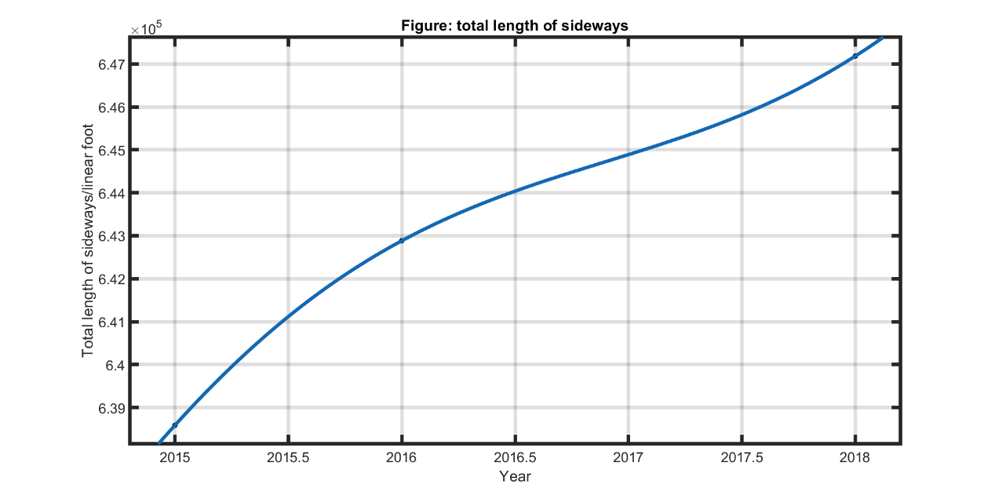

And the total length of sideways for a concrete year is:

Then the length of new roads built in a given year is:

As for planned maintenance sideways, they can be divided into two major categories: replacement and cutting&raising. For the replacement part, we believe that it mainly consists of damaged roads caused by factors such as climate influence during the previous year. Since climatic factors do not change significantly in the short term, we take their impact factor as a direct proportional coefficient with respect to time, that is, we assume that the annual proportion of the road length to be replaced to the total road length of the previous year due to climatic factors such as freeze-thaw effect and other influencing factors is . The length of roads to be replaced each year is:

With regard to cutting&raising part, we believe that the demand for cutting&raising sideway and replacement demand are consistent with each other. That is:

Due to the lack of direct data of cutting&raising sideway length, under the circumstance that cutting&raising budget in 2021 is known, we designed an indirect method to obtain cutting&raising budget.

Set the cutting&raising budget for 2021 as .

Through the above equation, we can get:

Meanwhile, based on our previous hypothesis, with regard to year, the ratio of cutting&raising unit cost to 2021 is. Therefore, with regard to year , its cutting&raising budget is:

**3.Establishment of budget forecasting model:**

The annual demand budget can be obtained from the sum of the unit cost of the year and the corresponding length of the repaired road. Based on the above process, we establish the following budget forecasting model:

By making a difference between the projected budget for each year and the previous year, the annual budget growth in question is obtained:

#### 6.3 Model Solution

**1.To solve the parameters of the fitting function:**

By using MATLAB software, the parameter values of each fitting function were obtained as follows:

The residual variances obtained by fitting are respectively:

Finally, the projected 2020-2045 budget and budget growth are given:

|  |  |  |
| --- | --- | --- |
| Year | Budget/$ | Budget Increase/$ |
| 2020 | 863446 | 1331 |
| 2021 | 865440 | 1994 |
| 2022 | 867468 | 2028 |
| 2023 | 868871 | 1403 |
| 2024 | 869566 | 695 |
| 2025 | 870120 | 554 |
| 2026 | 871231 | 1111 |
| 2027 | 873086 | 1855 |
| 2028 | 875188 | 2102 |
| 2029 | 876813 | 1625 |
| 2030 | 877678 | 864 |
| 2031 | 878197 | 519 |
| 2032 | 879104 | 907 |
| 2033 | 880777 | 1673 |
| 2034 | 882890 | 2113 |
| 2035 | 884712 | 1822 |
| 2036 | 885783 | 1070 |
| 2037 | 886331 | 548 |
| 2038 | 887067 | 736 |
| 2039 | 888530 | 1463 |
| 2040 | 890590 | 2060 |
| 2041 | 892569 | 1980 |
| 2042 | 893866 | 1296 |
| 2043 | 894504 | 638 |
| 2044 | 895116 | 612 |
| 2045 | 896358 | 1242 |

### 7. Model Analysis

#### 7.1 Advantages

①Using the fuzzy comprehensive evaluation method, using the combination of AHP and quantitative function methods, while establishing weights through literature data, using quantitative functions to make the model more accurate;

②A scoring form is adopted in the model, and all indicators that affect the order of repair are quantified, making the model more rational and grounded;

③In the process of quantifying impact factors, reference indicators are involved. Instead of simply using the higher the better standard, we find a most suitable node through city data, set it as a full-point reference point, and then use The function model combines variables and constants of full-point reference data to construct a quantitative function;

④In the prediction trend of the model, by combining the big data found and using the function fitting method, the cost of repairing sidewalks in the next few years can be roughly effectively predicted.

#### 7.2 Disadvantages

①When using AHP, despite the support of more big data, there are still subjective factors in the conversion between the weights of various indicators, and the objectivity is lacking;

②There are still some problems in defining the full score reference value of some indicators. For example, when the population density index is used, we calculate the total population density of the area and set it as a full score. However, because the population is mobile, it cannot be simply passed through The calculation is based on the resident population, so there is no theoretical supporting evidence in this regard;

③In the calculation of the model, because there are some data missing, we can only roughly calculate the approximate interval of the data that needs to be used through the related data, so as to find our solution, so in the solution of the model, There is an error;

④Regarding the repair order index, because many small influencing factors are involved, we only selected the 4 large indicators given by the title; among the small indicators, we also selected 5 after combining the references of ADA. Indicators lack rational support for the choice of indicators.From the overall of our model, our model is very suitable for repairing the comprehensive

#### 7.3 Sensitivity

From the overall of our model, our model is very suitable for repairing the comprehensive evaluation system of order degree. Our model involves a. population density, b. proximity to schools, bus stops, governmental buildings, c. number of complaints, d . The physical condition of concrete slabs are four influencing factors, among which 4 indicators are included under the index d, ①the slabs should not be broken; ②the vertical displacement at the interface between adjacent slabs should never exceed ½ inch; ③the running slope of every slab should not differ from the slope of the road by more than 2%; ④the cross slope of each slab should be at least 1% and at most 2%, besides, we started some other factor indicators were also considered and substituted into the established model, but we found that these parts are too small for the repairing order compared with the main impact indicators studied in this article. Therefore, we chose to abandon these small factors in the simplified model, but in terms of the general framework, the comprehensive evaluation model of repairing order that we have established is feasible and efficient. However, we still cannot ignore that there are subjective factors in the calculation of weights when using AHP, so we use percentage fluctuations to build a model sensitivity analysis. After discussion and literature data, we finally choose its fluctuations as 5%. Under the fluctuation of this ratio, we take the population density of 108 East Green Street as an example to make a chart for evaluating the order of restoration.

By changing the proportional weight parameter of this indicator, we calculated the comprehensive evaluation scoring model of the repair order degree under fluctuation based on our model.

### A Report for the manager of The City of Ithaca

We have prepared a one page report for the manager of The City of Ithaca. Here is the report:

A report to the manager of the city of Ithaca

With the development of cities, people’s quality of life has also increased significantly. The reasonableness and stability of sidewalks are becoming more and more important. Therefore, we have done research based on the length, location and amount of road sections repaired by sidewalks in the past few years, and put forward several constructions.

**Model about repairing the sidewalk sequence**

We combined population density, number of complaints and other factors to do a detailed analysis of the data and literature search and reference. We believe that the physical condition of concrete slabs is the most important factor, because it involves the fundamentals of urban construction, which is the most fundamental. Secondly, we mentioned population density and the number of complaints, because population density reflects the frequent flow of people in an area. Places with high foot traffic should be repaired first to reduce the impact of sidewalk damage on pedestrians. In addition, the number of complaints is also important, and it is also an important indicator reflecting the flow of people. We have made a detailed scoring model. The higher the score, the priority of repairing.

**About the repair method**

We listed the amount of repair required for each plan, and rationally integrated all the plans, and made a model of the volatility function. Through the mathematical model, all the possibilities and the degree of volatility of the error were included, and then the unimodal function relationship was used to determine Indicates the relationship between the independent variables of different methods and the total amount to select the most suitable plan for the City of Ithaca among all the plans.

**About predictive models**

We use the literature and data we found to indirectly calculate the variable that predicts the amount of money needed to repair the sidewalk in the future, and use the annual increase or decreased ratios of the number of sidewalk repairs to predict the sidewalk in the next few years. The number of miles needed to be repaired and using the method of selecting the best repair plan in Question C to calculate the most cost-effective amount, to calculate the amount in the next few years and use the method of function fitting to perform a highly reliable prediction of the amount of money spent on repairing the sidewalk.

Finally, we hope that our comprehensive evaluation model for the order of restoration of sidewalks, the best method of repairing sidewalks, and the model for predicting the amount of sidewalk repairs in the future can serve as a reference for your city and effectively help in urban management.

*Your humble political adviser Leo*

### Reference

* [1]Criminisi A, Reid I, Zisserman A. Single view metrology[j]. International Jornal of Computer Vision, 2000, 40 (2):123-148.[2] <https://econreview.berkeley.edu/healthcare-privatize-or-nationalize/>
* [2]https://price.pcauto.com.cn/price/nb49/#ad=8099, Car sales website
* [3]https://price.pcauto.com.cn/sg1994/, Car sales website
* [4] Chengzhi Li, Optimization measures for pavement of sidewalks at intersections of municipal roads, Sicuan Building Materials, 2020.8.10

### Appendix

The derivation process of the width of slab

Image measurement uses several properties of camera imaging, that is, small hole imaging. The camera treats parallel lines as intersecting lines on the image. In other words, parallel lines intersect at infinity, and these intersections form the horizon.The camera projects the three-dimensional space onto the two-dimensional image, keeping the straight line cross ratio unchanged. That is to say, if there are four points on a straight line in the three-dimensional space, then the intersection of the four points mapped to the picture is not changing. Literature# gives the formula for calculating the length from the picture through these conditions. The following gives us the process of calculating the length.

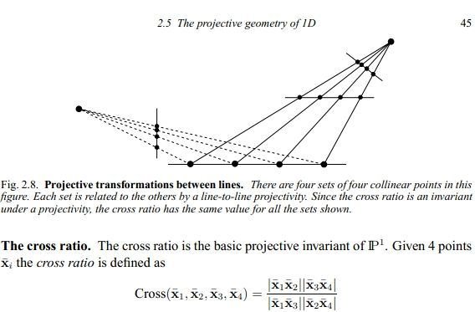

For example, we need to find the height of the villain through photos, and the height of the blue villain is known. In order to simplify the model, we simplified the character into a line segment, using lowercase letters to represent the image in the photo, and uppercase letters to represent actual points.

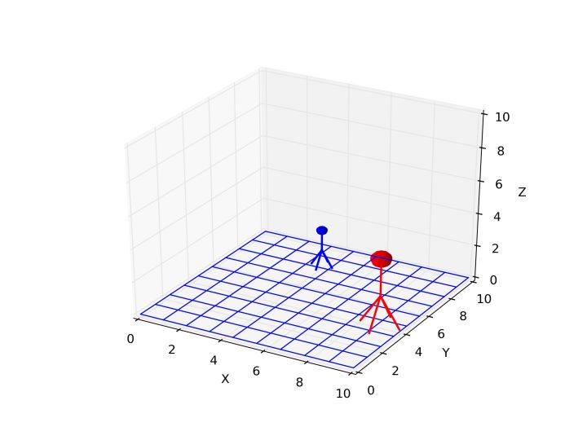

It can be seen from the figure that **ADEB** is a parallelogram. We know the length of **EB**, we can know the length of **AD**, and the length of **AF** is required. What we need is **AD/AF.**

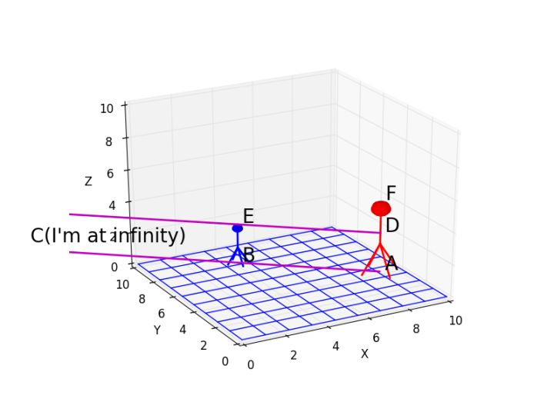

The extension line of **de** and the extension line of ab intersect at point c at infinity, and the extension line of **eb** and **da** intersect at point g at infinity.

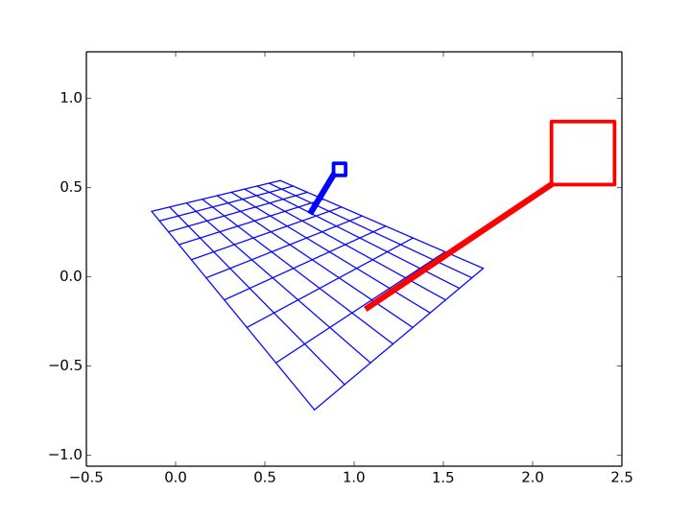

abed is the image of the flat quadrilateral **ABED** in real space.

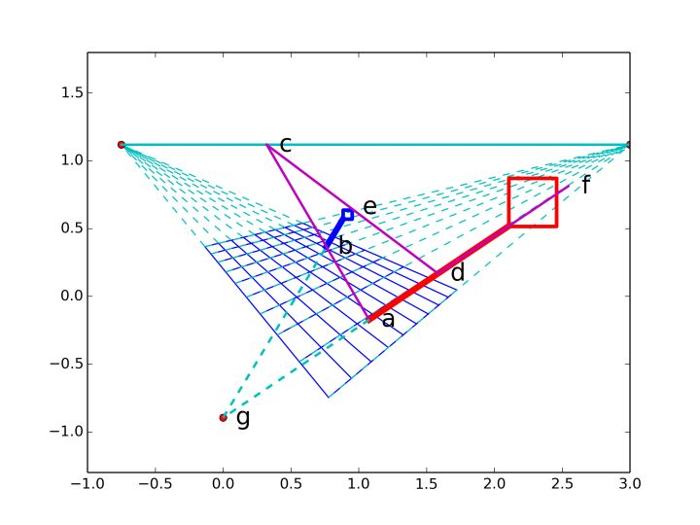

However, even if you know the image of certain line segments on the image, their actual length cannot be measured from the image because the depth of each point is different. At this time, we need to use the property that the intersection ratio of 4 points on a straight line before and after imaging is constant, and examine the ratio of A D F and the point G extending to infinity, we can get

**(AD/AF)/(GD/GF)=(ad/af)/(gd/gf)**

Because the length of ad has been calculated, all the quantities on the right side of the equation can be measured from the image. The point G on the left is the intersection of all vertical straight lines in real space. This point is at infinity. Therefore, the base Ratio **GD/GF=1**, so you can get the final result

**AD/AF=(ad/af)/(gd/gf)**

In this question, Wc/W=(ad/af)/(gd/gf)

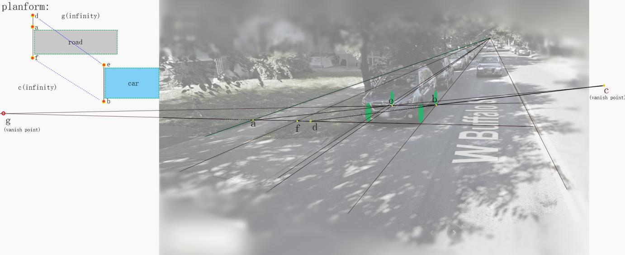

By investigating the make and model of the car in the picture, we know that the car in the picture is called Subaru-Outback, with a width of Wc=1.84 meters.

|  |  |  |  |  |  |  |  |  |
| --- | --- | --- | --- | --- | --- | --- | --- | --- |
|  | A1 | A2 | A3 | A4 |  | weight |  | congruity |
| A1 | 1.00000 | 4.00000 | 2.00000 | 0.33333 |  | 0.2289 |  | CI= |
| A2 | 0.25000 | 1.00000 | 0.33333 | 0.20000 |  | 0.068 |  | 0.055 |
| A3 | 0.50000 | 3.00000 | 1.00000 | 0.16667 |  | 0.1308 |  | CR= |
| A4 | 3.00000 | 5.00000 | 6.00000 | 1.00000 |  | 0.5723 |  | 0.0618 |
|  |  |  |  |  |  |  |  |  |
|  | a1 | a2 | a3 | a4 |  |  |  |  |
| a1 | 1.00000 | 5.00000 | 3.00000 | 4.00000 |  | 0.5409 |  | CI= |
| a2 | 0.20000 | 1.00000 | 0.33333 | 0.33333 |  | 0.0758 |  | 0.037 |
| a3 | 0.33333 | 3.00000 | 1.00000 | 2.00000 |  | 0.2298 |  | CR= |
| a4 | 0.25000 | 3.00000 | 0.50000 | 1.00000 |  | 0.1535 |  | 0.0416 |